Yulia Levin

Pianist / Music and Language Coach

Yulia Levin was born in Moscow.
After her studies in her home town, in Toronto and New York she worked for several years at the Los Angeles Opera.
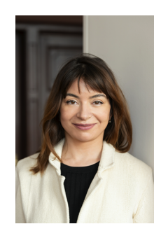
In 2010 she became solo repetitor at Zurich Opera, where she also works as a pianist with the orchestra and as coach for Russian language.

She is very committed to contemporary music. In Zurich she worked as an assistant to Michael Boder for Eötvös‘ Drei Schwestern, to Marc Albrecht for Zimmermann’s Die Soldaten, to Erik Nielsen for Trojans Orest and to Gabriel Feltz for Rihm’s Hamletmaschine.

Since 2017 she regularly works for the Salzburg Festival, lately as a director of studies upon personal invitation by Mariss Jansons and Valery Gergiev, whom she assisted for their opera productions.

Recently she worked as an assistant to Daniele Rustioni for The golden cockerel in both Lyon and Aix-en-Provence and to Fabio Luisi in Naples for Eugene Oneguin.
At the Salzburg Festival 2022 she accompanied the new productions of Bartók’s Duke Bluebeard’s Castle and of Orff’s De tempore fine comedia as well as Shostakovich’s symphony no. 13.

Yulia Levin is highly estimated by many singers as an accompanist for song recitals and by chamber music ensembles as a pianist.
She played concerts in Canada, in the US and in several European cities.

07/2023

